

**WAEP Semester Two Examination, 2018**

**Question/Answer booklet**

**MATHEMATICS**

**METHODS**

**UNITS 1 AND 2 Section Two:**

**Calculator-assumed**

If required by your examination administrator, please place your student identification label in this box

Student number: In figures

|  |  |
| --- | --- |

|  |  |  |
| --- | --- | --- |

|  |  |  |
| --- | --- | --- |

In words ______________________________________

Your name ______________________________________

**Time allowed for this section**

Reading time before commencing work: ten minutes

Working time: one hundred minutes

**Materials required/recommended for this section**

***To be provided by the supervisor***

This Question/Answer booklet

Formula sheet (retained from Section One)

***To be provided by the candidate***

Standard items: pens (blue/black preferred), pencils (including coloured), sharpener, correction fluid/tape, eraser, ruler, highlighters

Special items: drawing instruments, templates, notes on two unfolded sheets of A4 paper, and up to three calculators approved for use in this examination

**Important note to candidates**

No other items may be taken into the examination room. It is **your** responsibility to ensure that you do not have any unauthorised material. If you have any unauthorised material with you, hand it to the supervisor **before** reading any further.

**METHODS UNITS 1 AND 2 2 CALCULATOR-ASSUMED**

**Structure of this paper**

| Section | Number of questions  available | Number of  questions to be answered | Working  time  (minutes) | Marks  available | Percentage of  examination |
| --- | --- | --- | --- | --- | --- |
| Section One:  Calculator-free | 8 | 8 | 50 | 52 | 35 |
| Section Two:  Calculator-assumed | 13 | 13 | 100 | 98 | 65 |
|  |  |  |  | **Total** | 100 |

F

**Instructions to candidates**

F

O

T

U

1. The rules for the conduct of examinations are detailed in the school handbook. Sitting this

C

examination implies that you agree to abide by these rules.

E

B

L

2. Write your answers in this Question/Answer booklet.

L

I

W

T

3. You must be careful to confine your response to the specific question asked and to follow

I

any instructions that are specified to a particular question.

S

A

A

4. Supplementary pages for the use of planning/continuing your answer to a question

E

R

have been provided at the end of this Question/Answer booklet. If you use these pages

A

to continue an answer, indicate at the original answer where the answer is continued,

S

I

H

i.e. give the page number.

T

N

I

5. Show all your working clearly. Your working should be in sufficient detail to allow your E

T

answers to be checked readily and for marks to be awarded for reasoning. Incorrect

I

R

answers given without supporting reasoning cannot be allocated any marks. For any

W

question or part question worth more than two marks, valid working or justification is T

required to receive full marks. If you repeat any question, ensure that you cancel the

O

N

answer you do not wish to have marked.

O

D

6. It is recommended that you do not use pencil, except in diagrams.

7. The Formula sheet is not to be handed in with your Question/Answer booklet.

**See next page** SN078-122-3

**CALCULATOR-ASSUMED 3 METHODS UNITS 1 AND 2**

**Section Two: Calculator-assumed 65% (98 Marks)**

This section has **thirteen (13)** questions. Answer **all** questions. Write your answers in the spaces provided.

Working time: 100 minutes.

**Question 9 (6 marks)** (a) A sequence is defined by ����+1 = ���� − 1.8, ��1 = 975. Determine

(i) the value of ��120. (1 mark)

D

O

N

O

T

(ii) the sum of the first 120 terms of this sequence. (2 marks)

W

R

I

T

E

I

N

T

H

I

S

A

R

E

A

A

S

I

T

W

(b) Another sequence is defined by ���� = 975(0.2)��−1. Determine

I

L

L

B

(i) the value of ��5. (1 mark)

E

C

U

T

O

F

F

(ii) the value ���� approaches as �� → ∞. (2 marks)

SN078-122-3 **See next page**

**METHODS UNITS 1 AND 2 4 CALCULATOR-ASSUMED**

**Question 10 (6 marks)** The variables �� and �� are related by the equation 2�� + 5�� = 15.

(a) Sketch the graph of this relationship. (2 marks)

F 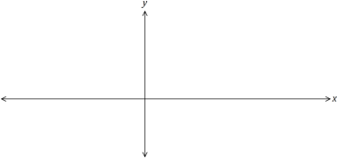

F

O

T

U

C

E

(b) Express �� in terms of �� and briefly explain why �� is a function of ��. (2 marks)

B

L

L

I

W

T

I

S

A

A

E

R

A

S

I

H

T

N

I

E

(c) The domain of �� is restricted to −5 ≤ �� < 10. State the range of ��. (2 marks)

T

I

R

W

T

O

N

O

D

**See next page** SN078-122-3

**CALCULATOR-ASSUMED 5 METHODS UNITS 1 AND 2**

**Question 11 (9 marks)**

The temperature �� of a cast taken out of an oven cools according to the model �� = 840(0.94)��, where �� is the time in minutes since the cast was removed from the oven. �� is measured in °��.

(a) Determine the fall in temperature of the cast during the first 5 minutes. (2 marks)

(b) Graph the temperature of the cast against time on the axes below. (4 marks)

D

O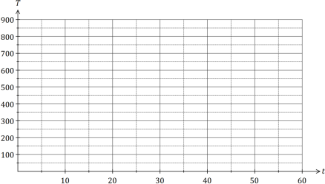

N

O

T

W

R

I

T

E

I

N

T

H

I

S

A

R

E

A

A

S

I

T

W

I

L

L

B

E

C

U

T

O

(c) State the name of this type of function. (1 mark) F

F

(d) The temperature of the cast falls to room temperature of 15°��.

(i) Determine the time taken for the cast to reach room temperature. (1 mark) (ii) Comment on the usefulness of the model for large values of ��. (1 mark)

SN078-122-3 **See next page**

**METHODS UNITS 1 AND 2 6 CALCULATOR-ASSUMED**

**Question 12 (8 marks)**

(a) Calculate the area of the minor segment that subtends an arc of 72° in a circle of diameter 170 cm. (2 marks)

(b) A chord of length 26 cm subtends an angle of ��17 at the centre of a circle. Calculate the

F

radius of the circle. (2 marks) F

O

T

U

C

E

B

L

L

I

W

T

I

S

A

A

E

(c) Parallelogram �������� has side ���� = 28 cm, side ���� = 19 cm and an area of 400 cm2.

R

A

Determine the lengths of the diagonals of ��������. (4 marks)

S

I

H

T

N

I

E

T

I

R

W

T

O

N

O

D

**See next page** SN078-122-3

**CALCULATOR-ASSUMED 7 METHODS UNITS 1 AND 2**

**Question 13 (8 marks)**

A mobile phone retailer classified recent sales of 625 phones by the age of customer and if the phone was bought outright or on a plan. A summary of the data is shown in the table below.

|  | Aged under 30 | Aged 30 or over | Total |
| --- | --- | --- | --- |
| Bought outright | 108 | �� | 232 |
| Bought on a plan | �� | 152 | �� |
| Total |  |  | 625 |

(a) Determine the values of ��, �� and �� shown in the table. (3 marks)

D

O

N

O

T

W

R

I

T

E

I

N

T

(b) A recent sale is selected at random from those recorded above. Event �� occurs if the H

I

customer was aged under 30 and event �� occurs if the phone was bought outright.

S

A

Determine the following probabilities:

R

E

A

(i) ��(��̅). (1 mark)

A

S

I

T

W

I

L

L

B

E

C

(ii) ��(�� ∪ ��). (1 mark)

U

T

O

F

F

(iii) ��(��̅∩ ��). (1 mark) (iv) ��(�� |��̅ ). (2 marks)

SN078-122-3 **See next page**

**METHODS UNITS 1 AND 2 8 CALCULATOR-ASSUMED**

**Question 14 (7 marks)** A function is defined by ��(��) =��44− ��3.

(a) Use the derivative ��′(��) to determine the coordinates of all stationary points of the function. (3 marks)

F

F

O

T

U

C

E

B

L

L

I

W

T

I

(b) Sketch the graph of �� = ��(��) on the axes below. (4 marks)S

A

A

E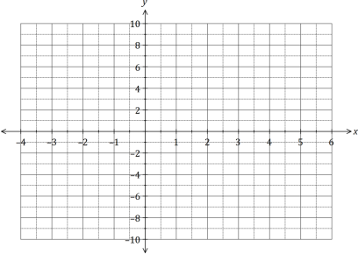

R

A

S

I

H

T

N

I

E

T

I

R

W

T

O

N

O

D

**See next page** SN078-122-3

**CALCULATOR-ASSUMED 9 METHODS UNITS 1 AND 2**

**Question 15 (7 marks)** (a) The graph of �� = sin �� is shown below. On the same axes, sketch �� = sin 2��. (2 marks)

D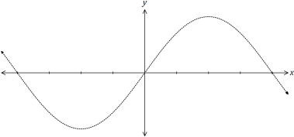

O

N

O

T

W

(b) The graph of �� = tan �� is shown below. On the same axes, sketch �� = tan (�� −��4), and all

R

I

T

its asymptotes. (3 marks) E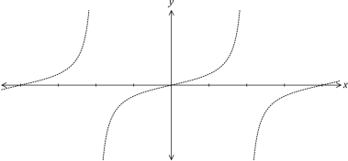

I

N

T

H

I

S

A

R

E

A

A

S

I

T

W

I

L

L

B

E

C

U

T

O

F

F

(c) The graph of �� = cos �� is shown below. On the same axes, sketch �� =12sin (�� +��2).(2 marks)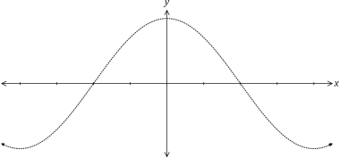

SN078-122-3 **See next page**

**METHODS UNITS 1 AND 2 10 CALCULATOR-ASSUMED**

**Question 16 (8 marks)**

A council took a random sample of 154 and 127 properties from suburbs �� and �� respectively. A total of 49 of the properties in the sample were in arrears with their rates, and 27 of these properties were in suburb ��. 'In arrears' means that payment of rates is overdue.

(a) Council officers wanted to choose 5 of the properties that were in arrears. How many different selections of properties are possible? (2 marks)

F

(b) Determine the probability that one randomly chosen property from the sample

F

O

T

(i) is in suburb �� and is in arrears. (2 marks)

U

C

E

B

L

L

I

W

T

I

S

A

A

E

R

A

(ii) is not in arrears given that it is in suburb ��. (1 mark)

S

I

H

T

N

I

E

T

I

R

W

T

O

N

O

(c) Justifying your answer with conditional probabilities, comment on whether being in arrears D

with rates is independent of the suburb the property is in. (3 marks)

**See next page** SN078-122-3

**CALCULATOR-ASSUMED 11 METHODS UNITS 1 AND 2**

**Question 17 (8 marks)**

Two water containers, initially empty, are being filled with water. The amount of water added to container �� each minute follows an arithmetic sequence, with 3 mL poured in during the first minute and 6 mL poured in during the second minute. The amount of water added to container �� each minute follows a geometric sequence, with 2 mL poured in during the first minute and 2.2 mL poured in during the second minute.

(a) The amount of water poured into container �� during the ��th minute is given by ��(��)��−1. State the value of the constants �� and ��. (2 marks)

D

O

N

O

T

(b) Determine the total amount of water in container �� at the end of the 25th minute.

W

(2 marks)

R

I

T

E

I

N

T

H

I

S

A

R

E

A

A

S

I

(c) How long does it take to fill container �� with 360 mL of water? (2 marks)

T

W

I

L

L

B

E

C

U

T

O

F

F

(d) Container �� first holds more water than container �� at the end of minute ��. (i) Determine the value of ��. (1 mark)

(ii) State, to the nearest mL, how much more water �� contains than �� at this time. (1 mark)

SN078-122-3 **See next page**

**METHODS UNITS 1 AND 2 12 CALCULATOR-ASSUMED**

**Question 18 (8 marks)**

The height, ℎ metres, above level ground of a seat on a steadily rotating Ferris wheel �� seconds after observations began was given by

ℎ = 6.5 cos (����25) + 8, �� ≥ 0.

(a) Draw the graph of the height of the seat against time on the axes below. (4 marks)

F 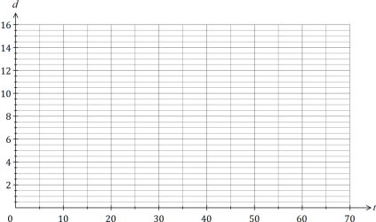

F

O

T

U

C

E

B

L

L

I

W

T

I

S

A

A

E

R

A

S

I

H

T

N

I

E

(b) How long did the Ferris wheel take to complete one revolution? (1 mark)

T

I

R

W

T

O

N

O

D

(c) At what time, when the seat was rising, did it first reach a height of 11 metres? (1 mark)

(d) Determine the change in height of the seat between �� = 130 and �� = 131, giving your answer rounded to the nearest cm. (2 marks)

**See next page** SN078-122-3

**CALCULATOR-ASSUMED 13 METHODS UNITS 1 AND 2**

**Question 19 (7 marks)**

(a) Part of the circle ��2 + ��2 = ���� + ���� + �� is shown below. Determine the values of the constants ��, �� and ��. (4 marks)

D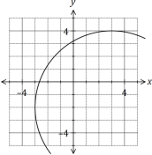

O

N

O

T

W

R

I

T

E

I

N

T

H

I

S

(b) The graph of a power function �� = ��(��) is shown below.

A

R

E

A

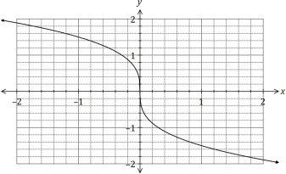

A

S

I

T

W

I

L

L

B

E

C

U

T

O

F

F

(i) Draw the tangent to the curve when �� = −0.5. (1 mark) (ii) Use the tangent to estimate ��′(−0.5). (2 marks)

SN078-122-3 **See next page**

**METHODS UNITS 1 AND 2 14 CALCULATOR-ASSUMED**

**Question 20 (8 marks)**

A diagnostic test for a disease has a 97% chance of giving the correct outcome and it is known that 0.5% of all sheep on a station have the disease. It can be assumed that the correct outcome of the test is independent of whether a sheep has the disease.

(a) A sheep is randomly selected for the test from those on the station. Determine the probability that

(i) the sheep has the disease, but the test indicates that it does not. (2 marks)

F

F

O

T

(ii) the sheep actually has the disease if the test indicates that it does. (4 marks)

U

C

E

B

L

L

I

W

T

I

S

A

A

E

R

A

S

I

H

T

N

I

E

T

I

R

W

T

O

N

O

D

(b) Two sheep are randomly selected for the test from those on the station. Determine the probability that just one of the sheep is diagnosed correctly. (2 marks)

**See next page** SN078-122-3

**CALCULATOR-ASSUMED 15 METHODS UNITS 1 AND 2**

**Question 21 (8 marks)**

A pyramid with a rectangular base of length �� and width �� has perpendicular height ℎ. The length of the base is three times its width and the sum of the width, length and height is 180 cm.

(a) Calculate the length, height and volume of the pyramid when �� = 15 cm. (2 marks)

D

O

(b) Show that the volume of the pyramid is given by �� = 180��2 − 4��3. (2 marks)

N

O

T

W

R

I

T

E

I

N

T

H

I

S

A

R

E

A

A

S

I

(c) Use calculus to determine the maximum volume of the pyramid and state the dimensions

T

W

required to achieve this volume. (4 marks)I

L

L

B

E

C

U

T

O

F

F

SN078-122-3 **End of questions**

**METHODS UNITS 1 AND 2 16 CALCULATOR-ASSUMED**

Supplementary page

Question number: _________

F

F

O

T

U

C

E

B

L

L

I

W

T

I

S

A

A

E

R

A

S

I

H

T

N

I

E

T

I

R

W

T

O

N

O

D

SN078-122-3

**CALCULATOR-ASSUMED 17 METHODS UNITS 1 AND 2**

Supplementary page

Question number: _________

D

O

N

O

T

W

R

I

T

E

I

N

T

H

I

S

A

R

E

A

A

S

I

T

W

I

L

L

B

E

C

U

T

O

F

F

SN078-122-3

**METHODS UNITS 1 AND 2 18 CALCULATOR-ASSUMED**

Supplementary page

Question number: _________

F

F

O

T

U

C

E

B

L

L

I

W

T

I

S

A

A

E

R

A

S

I

H

T

N

I

E

T

I

R

W

T

O

N

O

D

SN078-122-3

**CALCULATOR-ASSUMED 19 METHODS UNITS 1 AND 2**

Supplementary page

Question number: _________

D

O

N

O

T

W

R

I

T

E

I

N

T

H

I

S

A

R

E

A

A

S

I

T

W

I

L

L

B

E

C

U

T

O

F

F

SN078-122-3

© 2018 WA Exam Papers. Perth Modern School has a non-exclusive licence to copy and communicate this document for non-commercial, educational use within the school. No other copying, communication or use is permitted without the express written permission of WA Exam Papers. SN078-122-3.